Programming week 7

Stack and queues.

**Stacks and queues are used in collection, stacks are last in, first out collection of objects. While a queue is a first in, first out collection of objects.**

An example of a good use of stacks is the list of moves made in a chess game, when they want to go back on their last move, which is the most recent move. It is the first one retrieved (last-in) it is the first one retrieved (last-out)

Stack key terms –

Pop, Removes item from stack.

Peek, Returns object at the top of the stack without moving it.

The following code demonstrates adding and removing items from a stack. In this case, you’re using generics to implement a stack of ChessMove objects. The RecordMove method adds the most recent move to the stack. The GetLastMove method returns the most recent move on the stack.

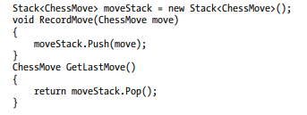

**An application that services help desk requests is a good example of when to use a queue.**

A collection is used to maintain a list of help requests sent to the application. When retrieved the first request (first-in) is the first one retrieved (first-out)

Queue Key terms –

Enqueue, adds item

Dequeue, removes item.

Peek, return item at start of queue without removing it.

AddRequest, adds a request to the queue.

GetNextRequest, removes request from the queue.

